Directions: Read each scenario with your group. Based off the scenarios, figure out characteristics that would be displayed under each abusive relationship.
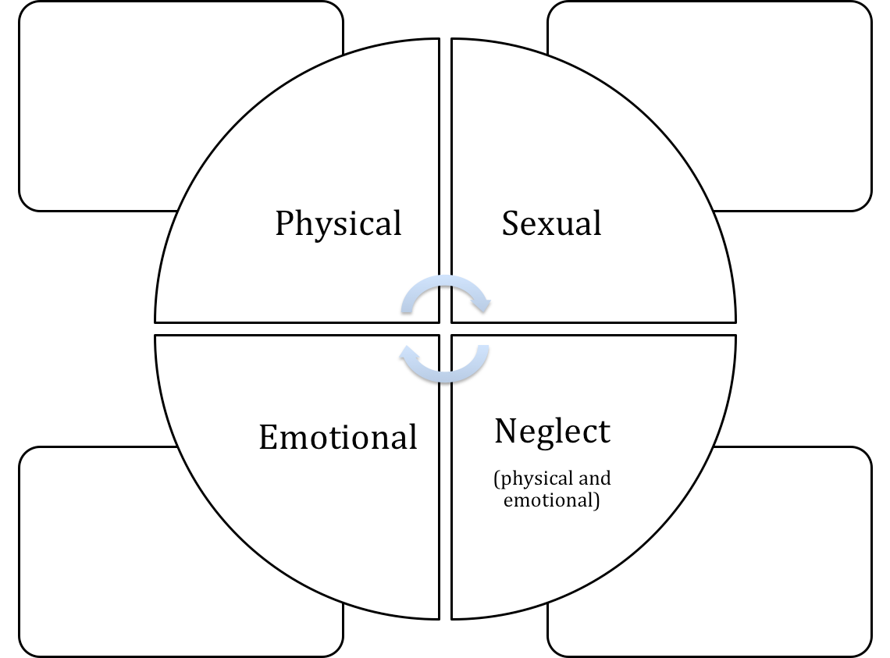

Reflection Questions:

1.If you notice a friend being abusive …. You should:

- _________________________________
- _________________________________
- _________________________________
- _________________________________

2. If you notice a friend in an abusive relationship…. You should:
- _________________________________
- _________________________________
- _________________________________
- _________________________________

